**Exp No.** 10 **Name:** PONNURI ANIRUDDHA

**Date**: 12/10/2022 **Reg No:** RA2112704010015

FIFO Page Replacement Algorithm

**Aim: --**

To implement FIFO page replacement algorithm.

**Procedure: --**

**Page Replacement algorithm:**

In operating systems that use paging for memory management, page replacement algorithms are needed to decide which page needs to be replaced when a new page comes in. Whenever a new page is referred and not present in memory, page fault occurs and the Operating System replaces one of the existing pages with a newly needed page. Different page replacement algorithms suggest different ways to decide which page to replace. The target for all algorithms is to reduce the number of page faults.

**CODE (FCFS): --**

*from queue import Queue*

*def pageFaults(pages, n, capacity):*

*# To represent set of current pages.*

*# We use an unordered_set so that we quickly check if a page is present in set or not*

*s = set()*

*# To store the pages in FIFO manner*

*indexes = Queue()*

*# Start from initial page*

*page_faults = 0*

*for i in range(n):*

*# Check if the set can hold more pages*

*if (len(s) < capacity):*

*# Insert it into set if not present already which represents page fault*

*if (pages[i] not in s):*

*s.add(pages[i])*

*# increment page fault*

*page_faults += 1*

*# Push the current page into the queue*

*indexes.put(pages[i])*

*# If the set is full then need to perform FIFO*

*# i.e. remove the first page of the queue from*

*# set and queue both and insert the current page*

*else:*

*# Check if current page is not*

*# already present in the set*

*if (pages[i] not in s):*

*# Pop the first page from the queue*

*val = indexes.queue[0]*

*indexes.get()*

*# Remove the indexes page*

*s.remove(val)*

*# insert the current page*

*s.add(pages[i])*

*# push the current page into*

*# the queue*

*indexes.put(pages[i])*

*# Increment page faults*

*page_faults += 1*

*return page_faults*

*# Driver code*

*if __name__ == '__main__':*

*pages = [7, 0, 1, 2, 0, 3, 0,*

*4, 2, 3, 0, 3, 2]*

*n = len(pages)*

*capacity = int(input("Enter number of page frames:--"))*

*print("Number of page faults: --",pageFaults(pages, n, capacity))*

**OUTPUT (FCFS): --**

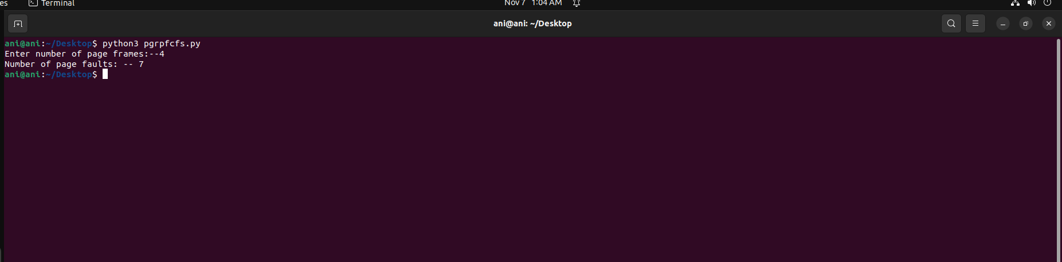

**RESULT: --**

The FIFO Page Replacement Algorithm is successfully implemented using python program.